Dear Parents,

These are the different portfolios:
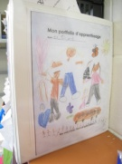
Portfolio d’apprentissage: -It is the black binder.
-It is used to store all your children’s creations.
-It is to be kept at home.

Portfolio de transport: -It is a blue duo tang with two “pochettes”.
-It is used to transport the children’s creations from
school to your home.
-It needs to be emptied and returned to school the next day.
-The content should be stored in the white binder.

Portfolio de presentation: -It is a green duo tang. It will be sent home later.
-It will be used to store selected pieces of your children’s creations.
-Your children will choose creations that are stored in their white binder and will put them in the green duo tang to show me at parent, child teacher interview (1st report card), portfolio night (2nd report card) and during class (3rd report card).

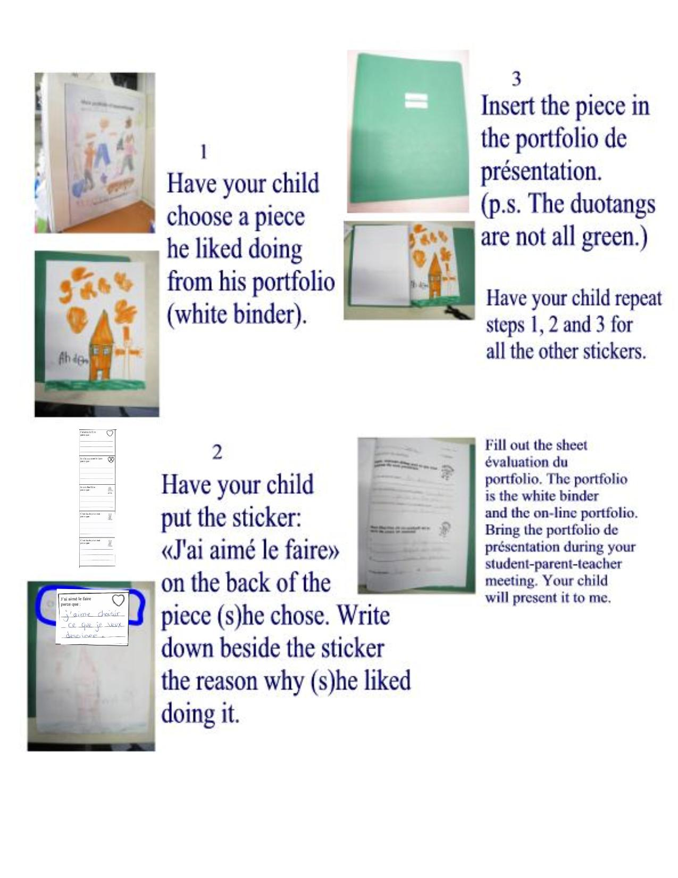
Portfolio numérique (on-line):- http://recitpresco.qc.ca/portfolio/
-It contains picture, videos and recordings of your children’s creations.
-It should be visited with your children.
-They ask me to take pictures, because they want to show you what they did. They are proud.
-You and your children can write comments and I will answer.
-Please see next page for instructions.

Instructions on-line portfolio

- http://recitpresco.qc.ca/portfolio/

Enter your child’s code.
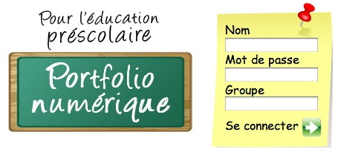
Nom : _____________
Mot de passe: _______
Groupe : ______
Cliquez sur « Se connecter »

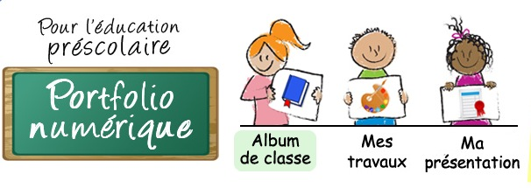

- To see pictures, videos,
listen to sounds of the different
class projects click on :
« Album de classe ».
(everyone in the class
can see this)
To see your child’s work click on
« Mes travaux ».
(only you can see this)

- In « Album de classe » click on the pictures to see everything related to that theme.

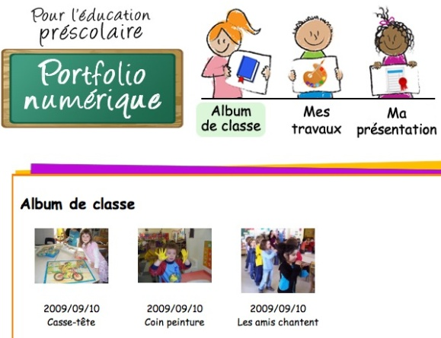

- In « Mes travaux » click on the pictures to see the description.
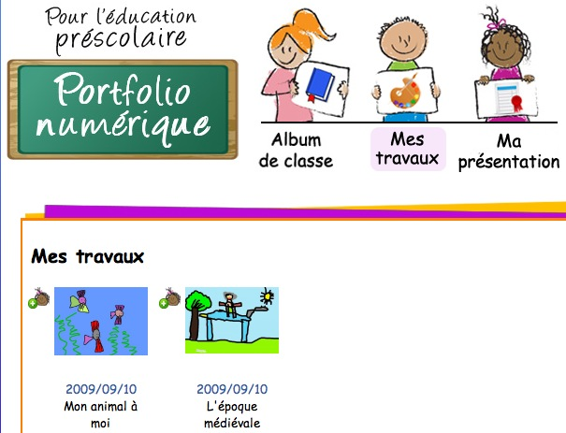

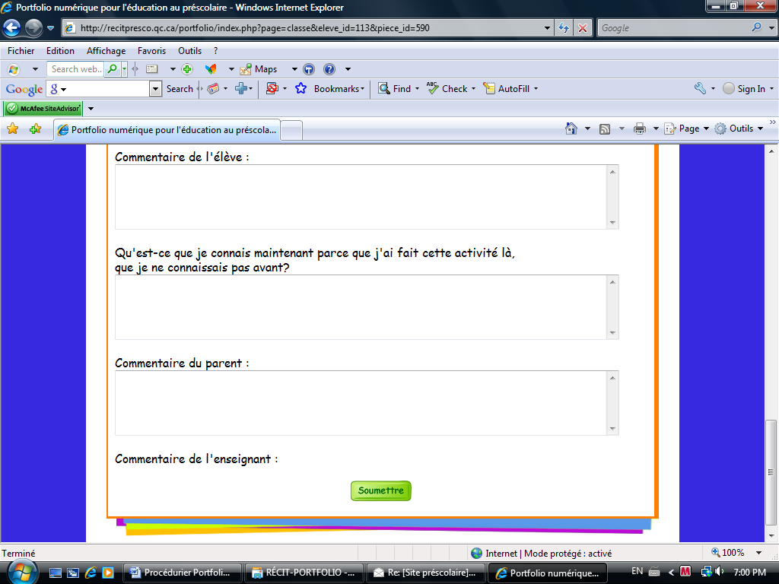
You can write your comment and your child’s comment. If you do, I will write a comment as well.

*Don’t forget to click on : « Soumettre »

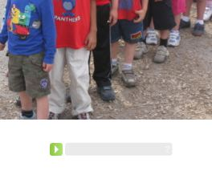
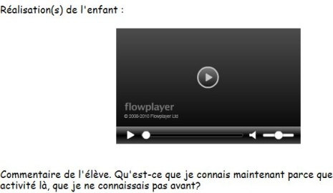

Click to hear sound Click to view video

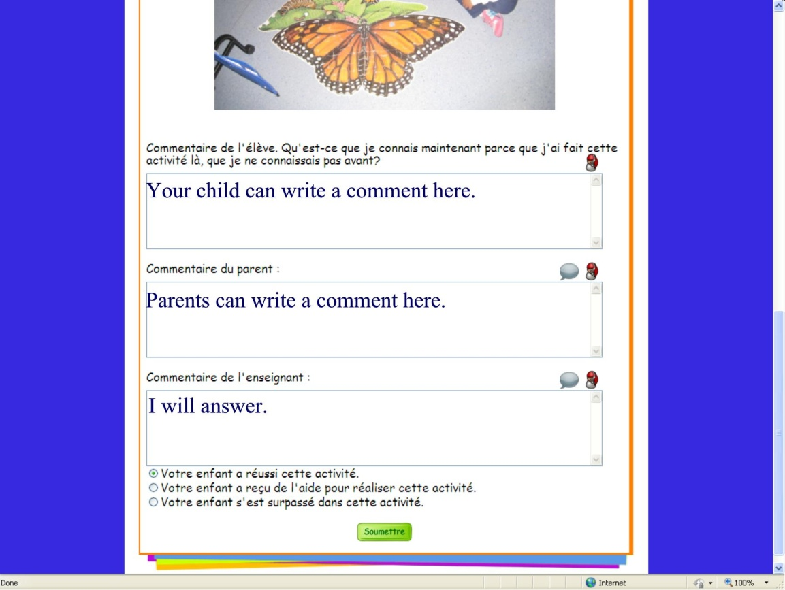

- Click on the green arrow
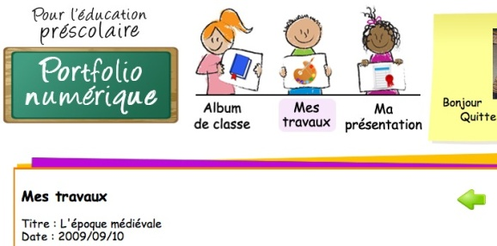
to come back to the previous page.

